Statistics Lecture 5.4: Finding Mean and Standard Deviation of a Binomial Probability Distribution

Notation:
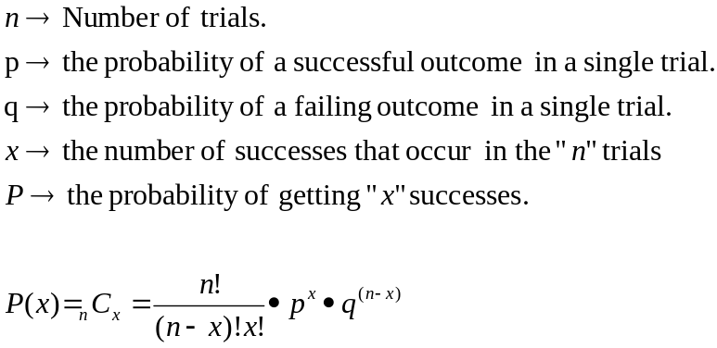

- Mean:
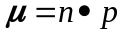

The number of successes you expect to occur from your procedure.

- Variance
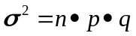

- Standard Deviation
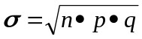

Example
A certain population is made up of 80% Hispanic Americans. Select a jury of 12

Find the mean and standard deviation.
Success: Failure:
Selecting a Hispanic Americans. Selecting any other ethnicity.
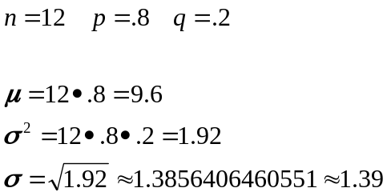

Usual 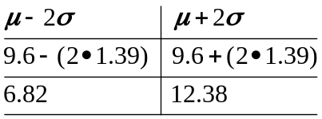

Example
Over a period of time, 870 people were selected for juries from this population.

Find the mean and standard deviation.

Success: Failure:
Selecting a Hispanic Americans. Selecting any other ethnicity.
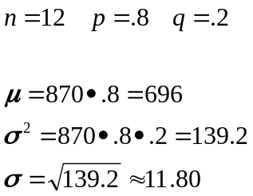

Usual 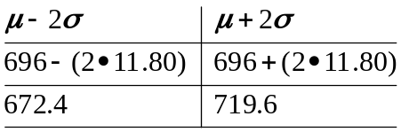

Only 275 Hispanic Americans were selected for juries.. (Very unusual)

